**Day-2. Practice problems array &strings**

**1.** C Program to Find C Program to calculate the largest two numbers in a given Array.  **problem Description**

We have to write a program in C such that the program will read the elements of a one-dimensional array, then compares the elements and finds which are the largest two elements in a given array.

**Expected Input and Output**

**Finding Largest 2 numbers in an array with unique elements:**

If we are entering 5 elements (N = 5), with array element values as 2,4,5,8 and 7 then,  
**The FIRST LARGEST** = 8  
**THE SECOND LARGEST** = 7

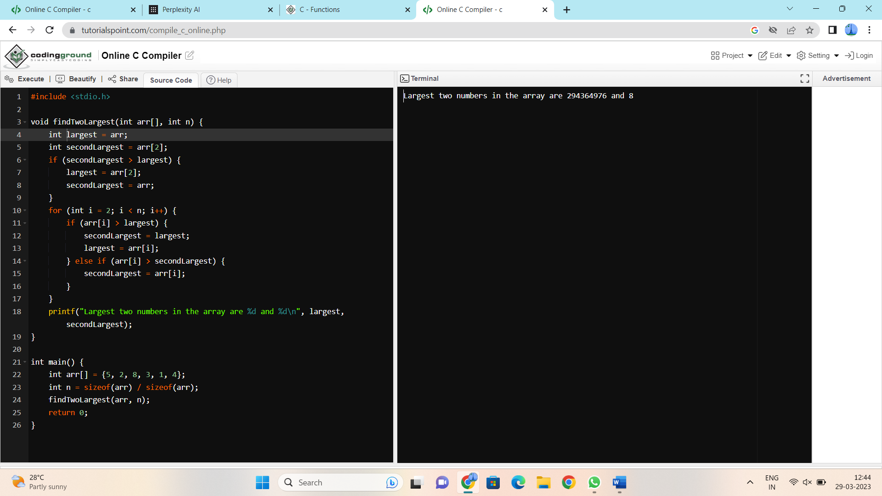

**2.**.C Program finds second largest & smallest elements in an Array. **Problem Description**

The program will implement a one-dimensional array and sort the array in descending order. Then it finds the second largest and smallest element in an array and also find the average of these two array elements. Later it checks if the resultant average number is present in a given array. If found, display appropriate message.

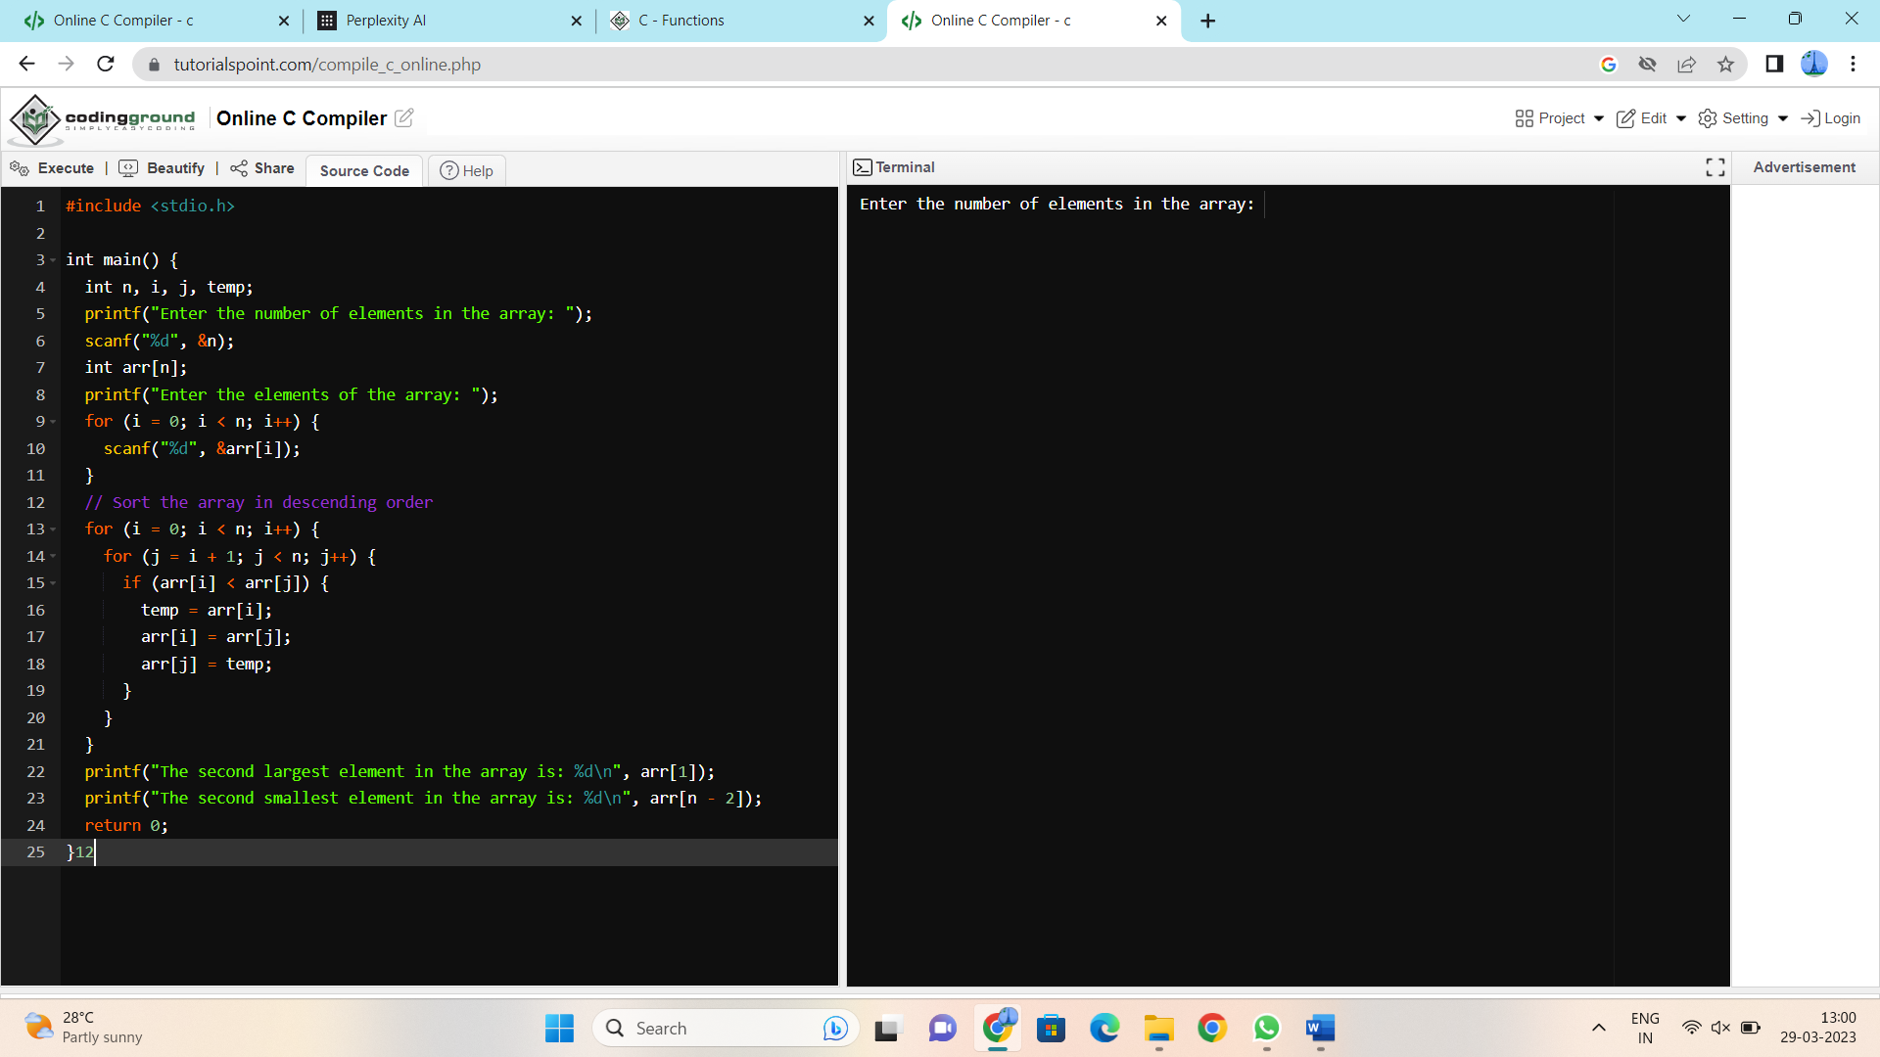

**3**.C Program to find the odd element given an array with only two different elements.

**Problem Description**

This C Program finds odd element in a given array with only two different element.

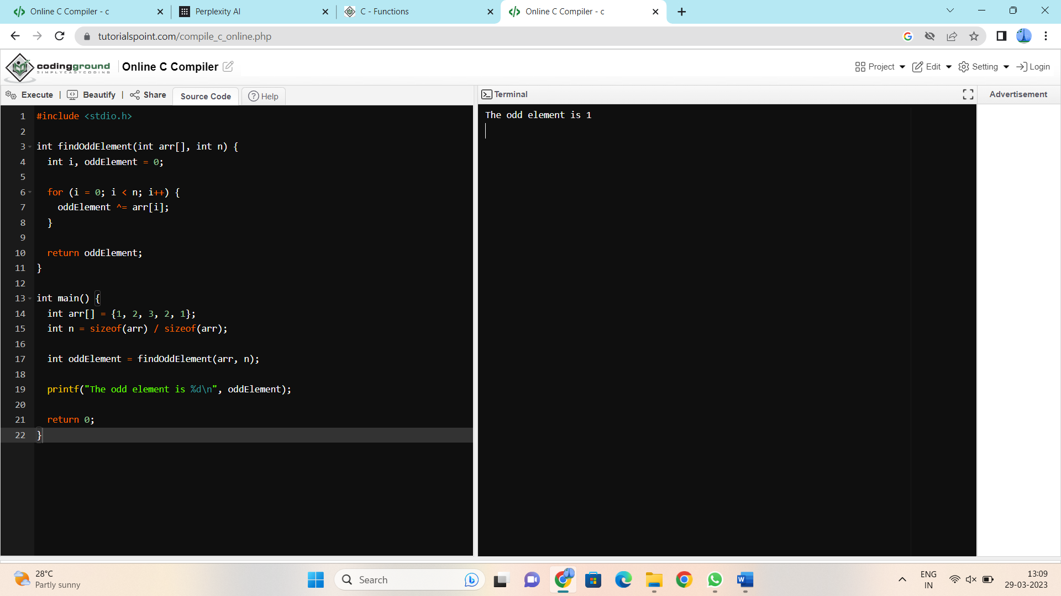

**4.** C Program to delete an element in an Array by index or value.

**Method 1: (Delete Element by Index)**In this approach, we will use a loop to iterate through the array and delete the element from the array.

**Example:**  
**Input:**  
Size of array = 5  
array = [8, 4, 9, 6, 2] Index of the element to be deleted is “3”

**Output:**  
[8, 4, 9, 2]

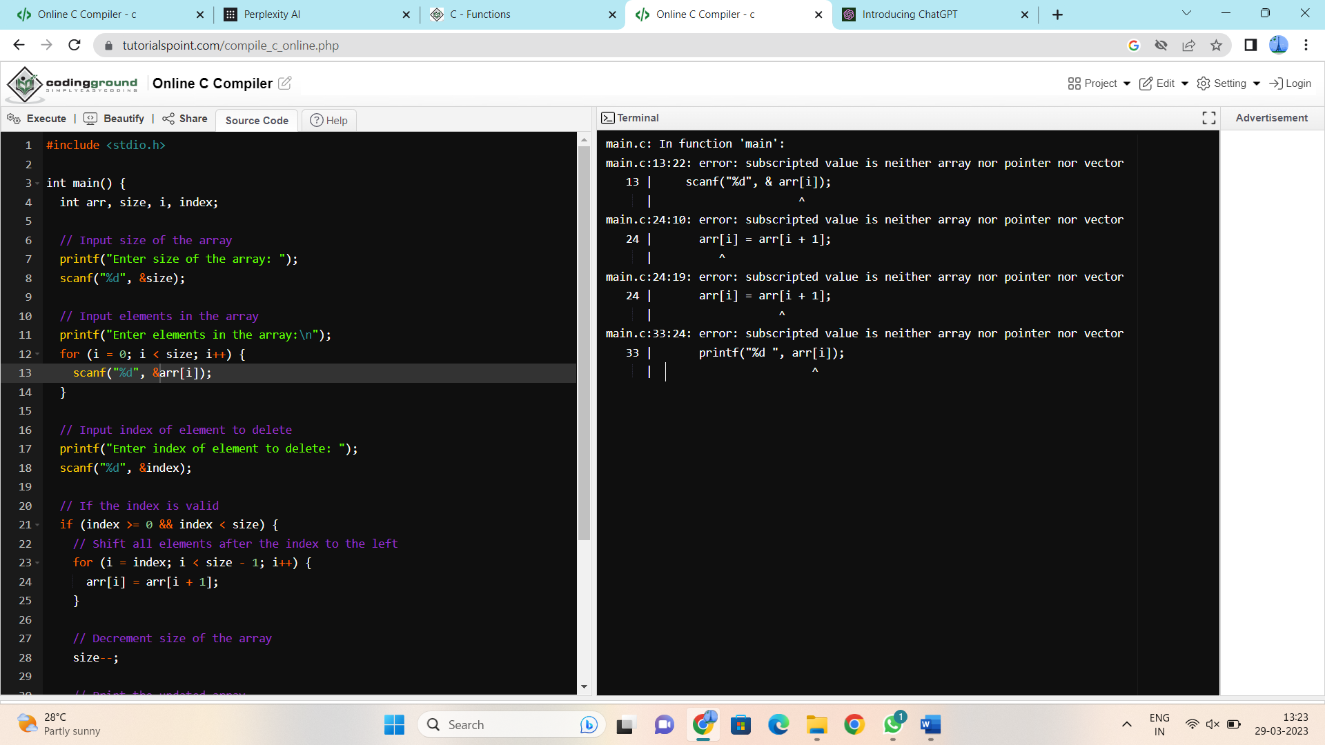

**5.** C Program to remove duplicate elements from an Array.

**Input Array:** 1,2,4,5,4,2,7,5

**Output:** Resultant Array after removing duplicates: 1,2,4,5,7

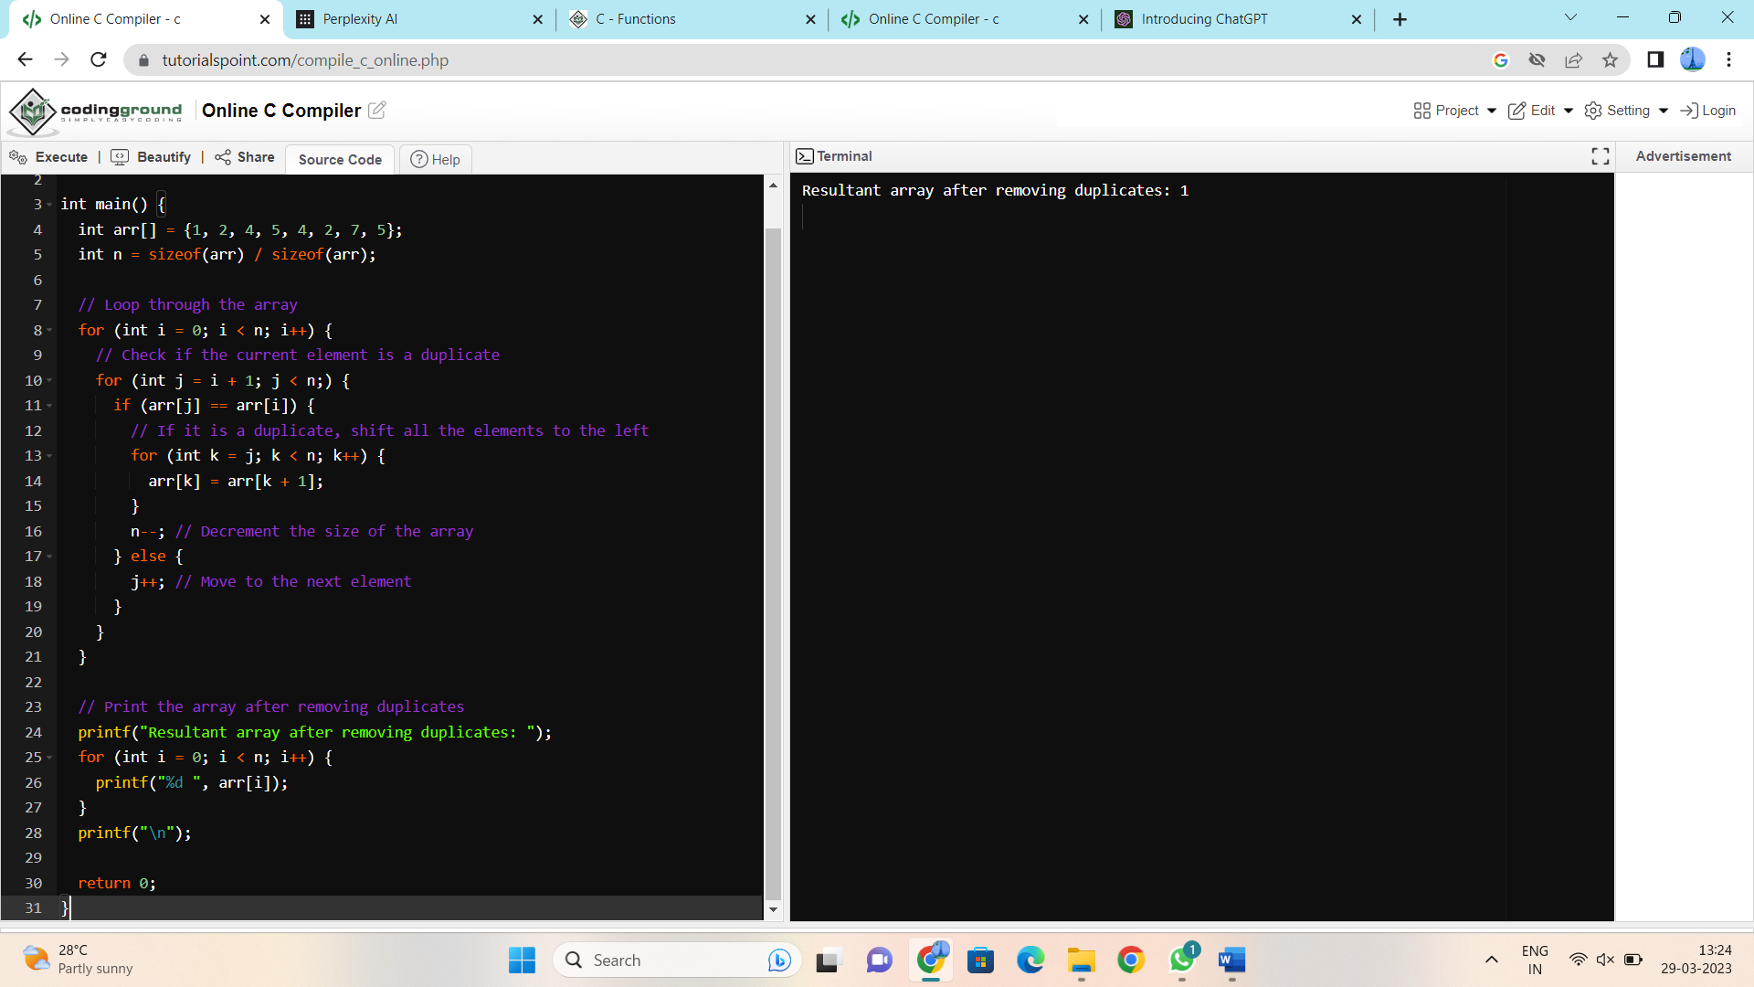

**6.** C Program to reverse an Array.

**Reversing an array** means substituting the last element in the first position and vice versa and doing such a thing for all elements of the array. For **example**, first element is swapped with last, second element is swapped by second last and so on.

Such arrays where the original and reversed arrays are equal are called palindrome arrays.

**Examples:**

**Input array:** [1,2,3,4]  
**Reversed array:** [4,3,2,1]

**Input array:** [3,2,1]  
**Reversed array:** [1,2,3]

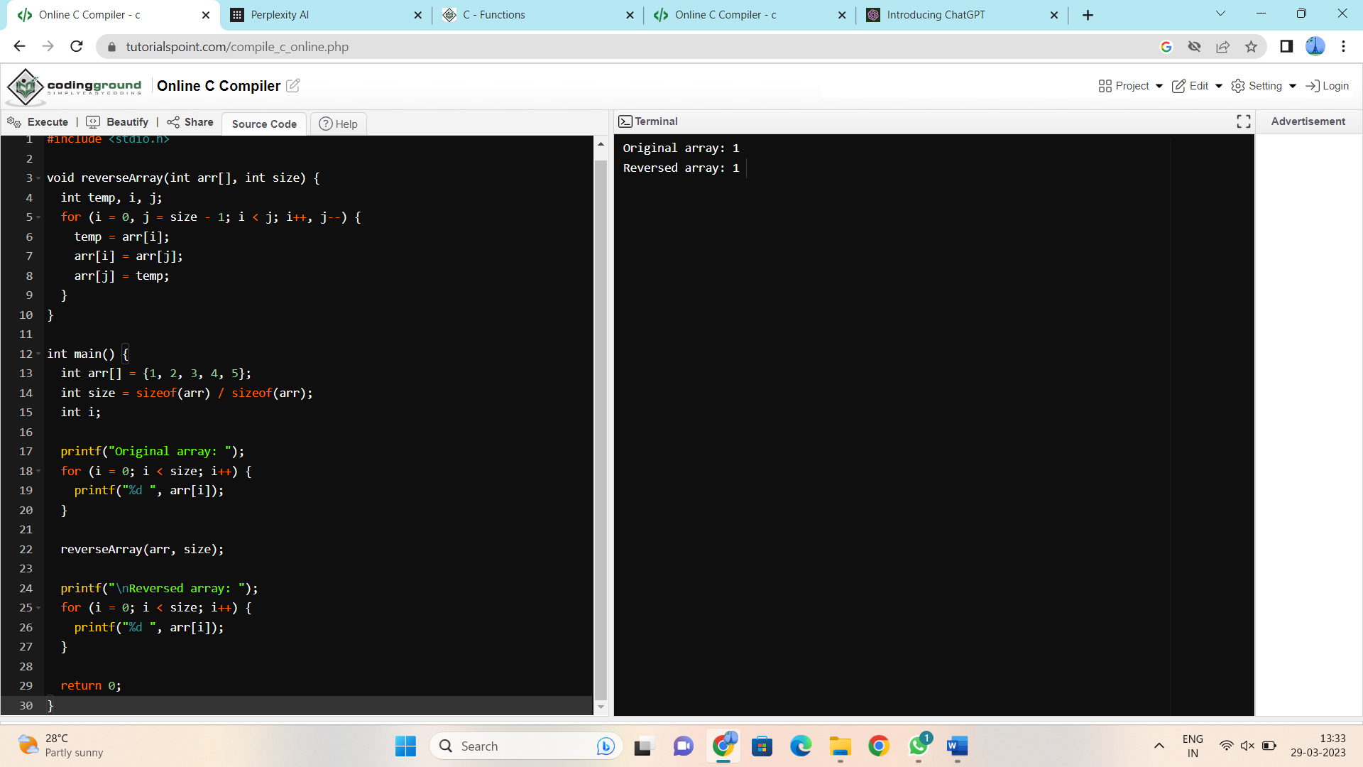

**7.** Write a C program to merge two sorted array elements into a single array.

**Merging two arrays** in c is similar to Concatenating or combining two arrays into a single array. For **example**, if the first array has four elements and the second array has five elements, the resulting array has nine elements.

**Example:**  
**First Array** = [1, 2, 3, 4, 5]  
**Second Array** = [6, 7, 8, 9, 10]

**Merged Array** = [1, 2, 3, 4, 5, 6, 7, 8, 9, 10]

**Problem Description**

Write a C program to merge two sorted array elements into a single array.

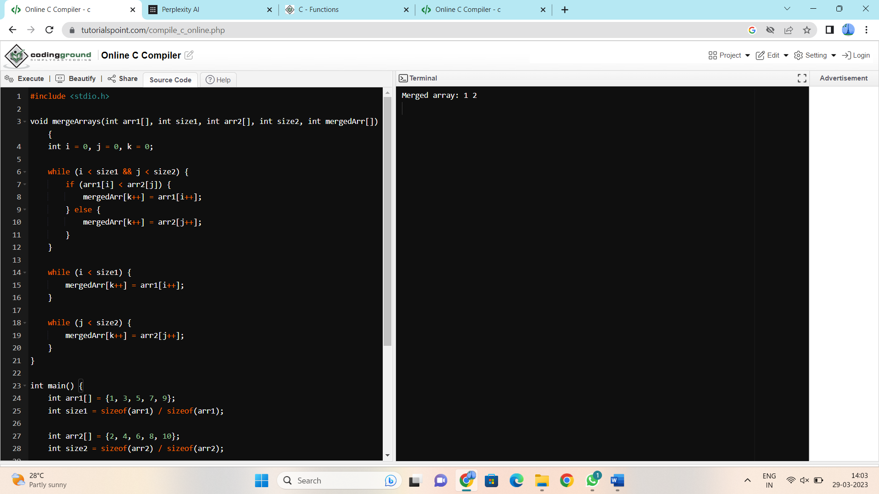

8. Write a program to find the number of composite numbers in an array of elements

**Sample Input:**

Array of elements = {16, 18, 27, 16, 23, 21, 19}

**Sample Output:**  
Number of Composite Numbers = 5

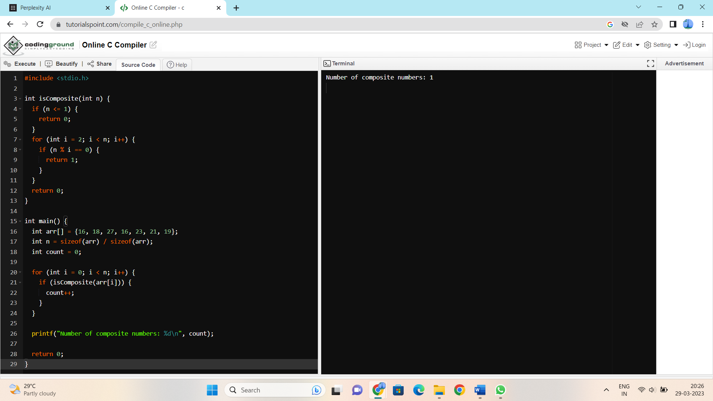

14. Write a Program to find the Maximum and Minimum value in a given array of numbers.

**Sample Input:**

Enter no. of elements in an array 5

Enter the elements:

1 2 3 4 5

**Output:**

Maximum of an array 5

Minimum of an array 1

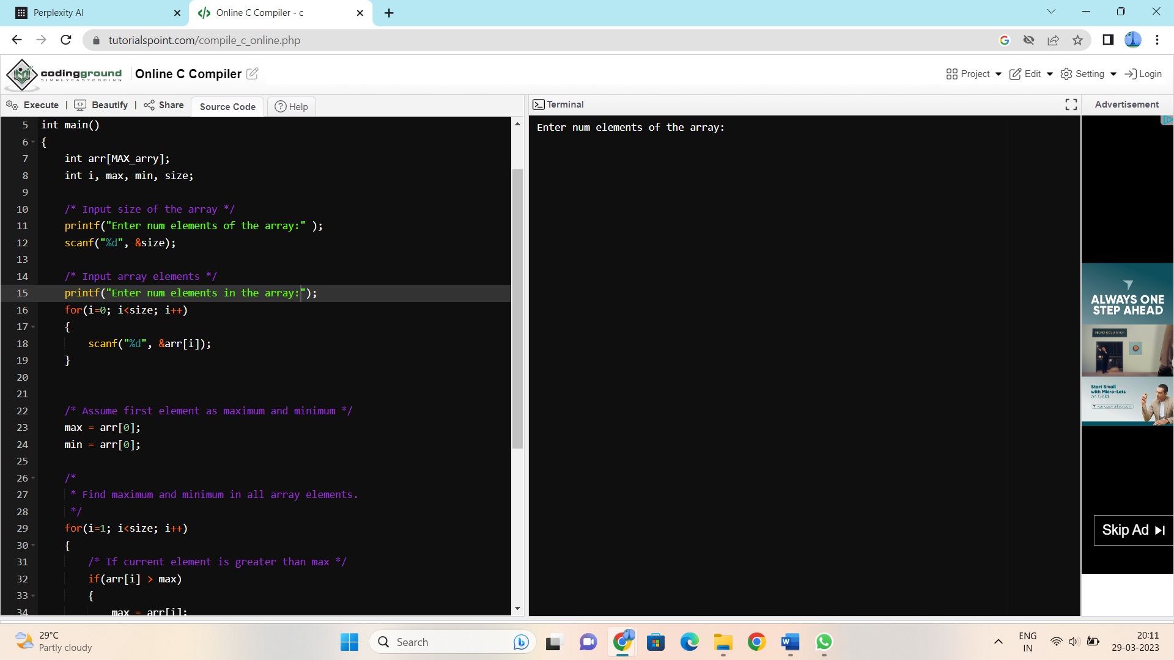

11. Write a program to search the given element and display its position in a linear array.

**Sample Input:**

Array of elements = {16, 18, 27, 16, 23, 21, 19}

Element to search = 23

**Sample Output:**  
Given element 23 is found at 5 th position

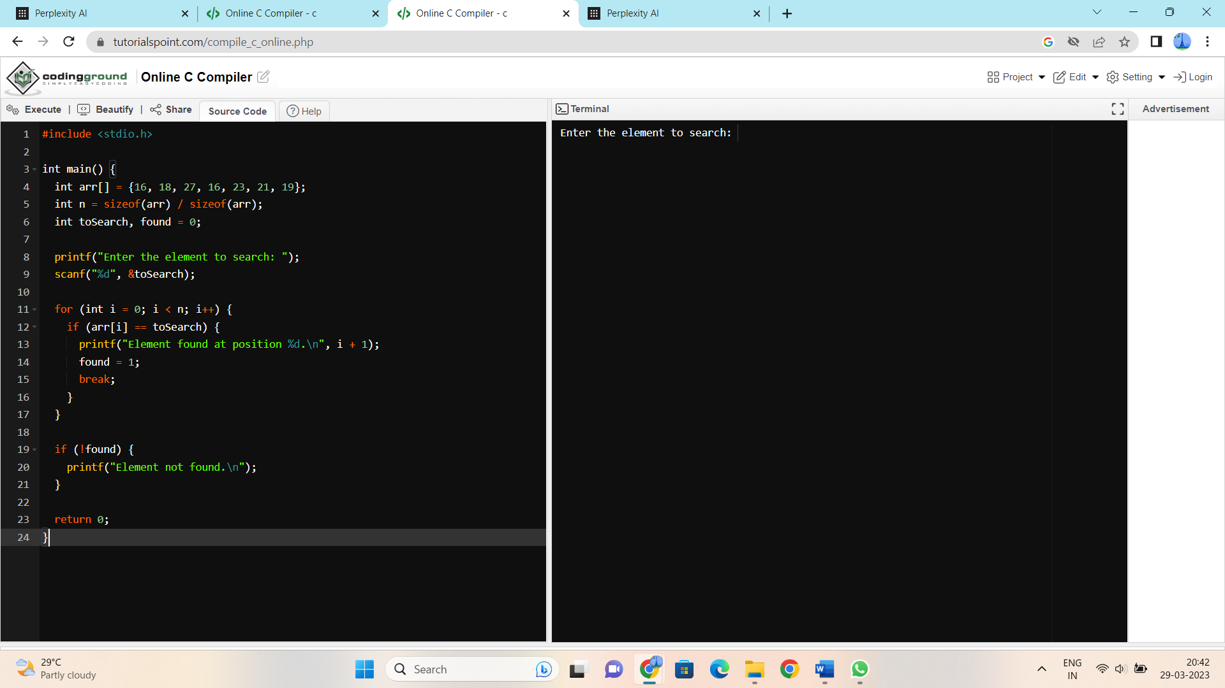

**12.**Write a program to find the sum and average of the elements in an array

**Sample Input:**

Array of elements = {16, 18, 27, 16, 23, 21, 19}

**Sample Output:**

Sum = 140

Average = 20

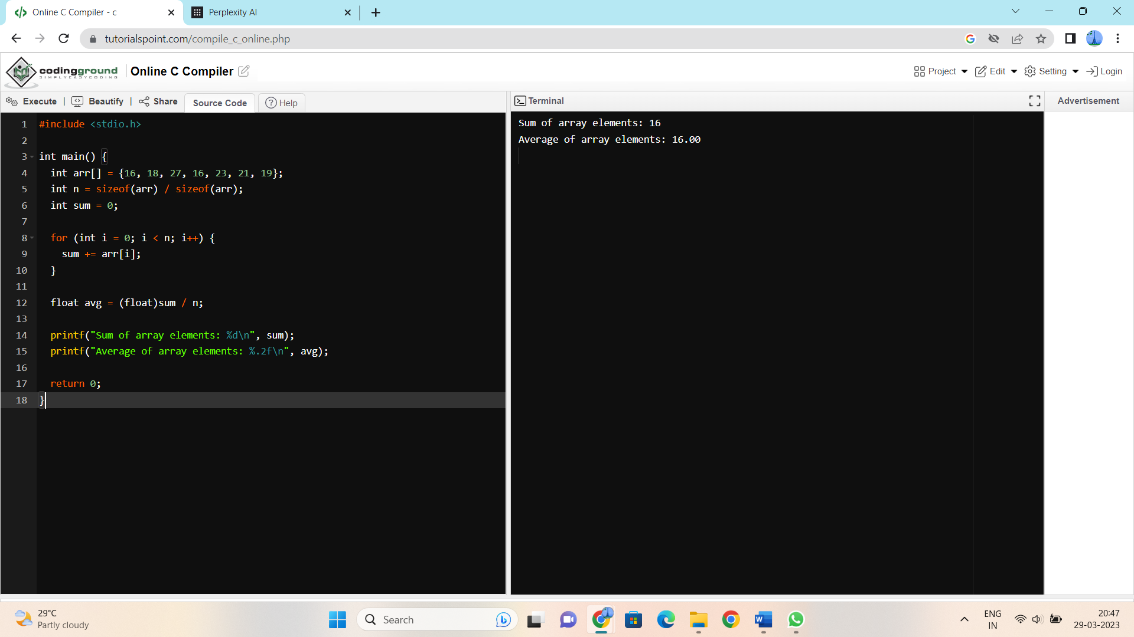

**13.** Write a Program to display the diagonal elements in a matrix array and also find the sum of them.

**Sample input:**

1 2 3

4 5 6

7 8 9

**Output:**

Diagonal Elements are 1 5 9

Sum of diagonal elements = 15

